# Project Introduction

Herbal drugs (also flavoringism) is that the study of pharmacognosy and therefore the use of healthful plants. Plants are the premise for medical treatments through most of human history, and such ancient drugs continues to be wide practiced these days fashionable drugs makes use of the many plant-derived compounds because the basis for evidence-based pharmaceutical medicine. though herbalism might apply fashionable standards of effectiveness testing to herbs and medicines derived from natural sources, few high-quality clinical trials and standards for purity or indefinite quantity exist. The scope of flavoring drugs is typically extended to incorporate flora and bee product, similarly as minerals, shells and sure animal elements.

Herbal drugs is additionally known as phyto-medicine or therapy. Paraherbalism describes various and unscientific practices of mistreatment unrefined plant or animal extracts as unproved medicines or health-promoting agents. Paraherbalism differs from plant-derived medicines in customary materia medica as a result of it doesn't isolate or standardize biologically active compounds, however rather depends on the assumption that conserving varied substances from a given supply with less process is safer or more practical – that there's no proof flavoring dietary supplements most frequently comprise the therapy class.

The World Health Organization (WHO) estimates that eighty p.c of the population of some Asian and African countries presently use flavoring drugs for a few side of primary health care, Prescription drugs square measure prohibitively high-ticket for many of the world's population, half whom lived on but $2 U.S. compared, flavoring medicines may be mature from seed or gathered from nature for small or no price.

Many of the prescription drugs presently offered to physicians have a protracted history of use as flavoring remedies, as well as artemisin in, opium, aspirin, digitalis, and antimalarial. In keeping with the planet Health Organization, or so twenty fifth of recent medicine utilized in the u. s.a minimum of seven,000 medical compounds within the fashionable collection square measure derived from plants. Among the one hundred twenty active compounds presently isolated from the upper plants and wide utilized in fashionable drugs these days, eightieth show a direct correlation between their fashionable therapeutic use and therefore the ancient use of the plants from that they're derived.

# Analysis OBjectives

Here are the list of question whose analysis which be given below..

1. What is the relation between the successive years and the new changes to a herbal medicine?
2. What is the relation between the successive years and the average time to store a medicine in an inventory?
3. What are the alternative medicines for a particular problem/disease?
4. Number of alternative medicines added in the last 5 years and if any new medicine is formed?
5. Number of new medicines publishes in the last 10 years.
6. Number of new medicines added to the invontory in the last 10 years.
7. Number of new medicines revised/upgraded in the last 10 years.

# Data Acquisition and Cleaning

**Code to read the data from Excel / CSV / HTML.**

To read the dataset in xlsx format, we will load it into Pandas data frame but first let’s import the pandas library and set an alias by typing **“import pandas as pd”**. After importing the library with the alias **“pd”**, let us load the .xlsx file using the following line of code:

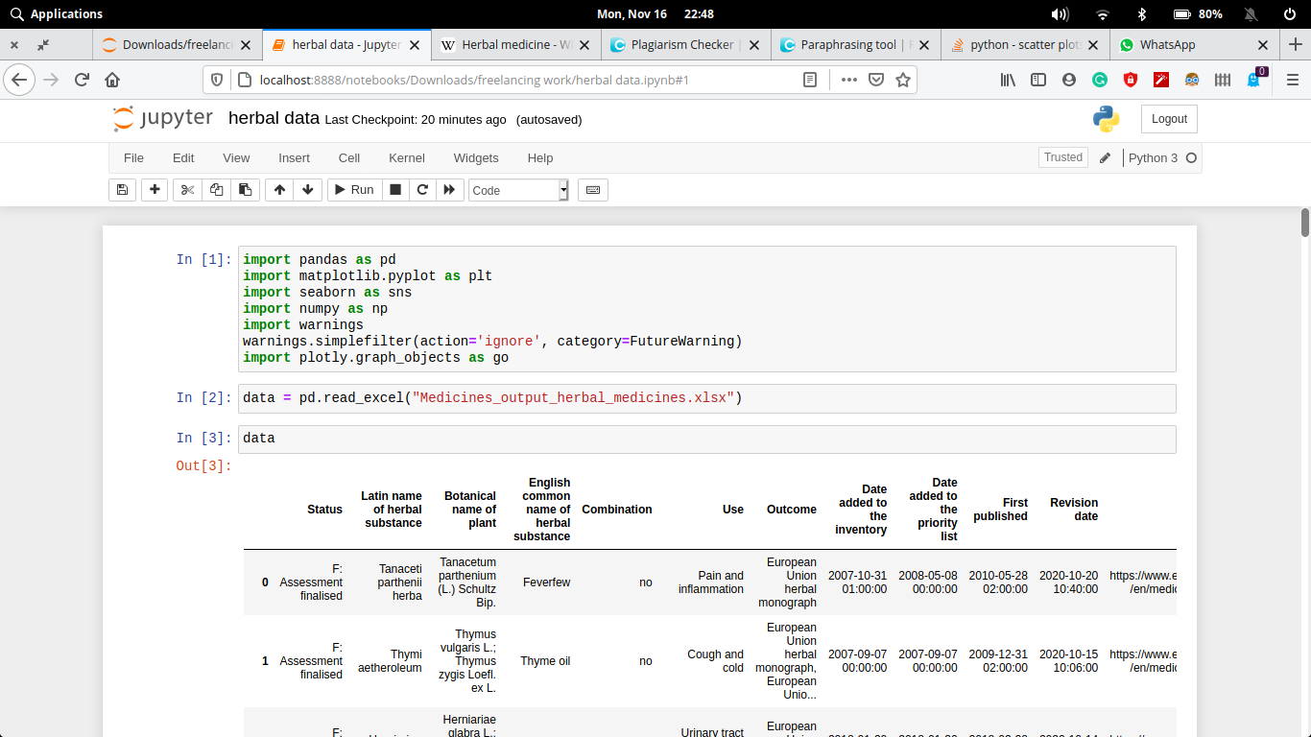

Here we have import our xlsx files and read through pandas library.

Here the xlsx file can be read through (Pandas library) and store in **data Dataframe**. The Dataframe can be shown through **.head()**. The number of rows we want to show, that number we have to pass in head parentheses as an argument.

Now if we want to describe our dataframe for our better understanding to know the stats. and other parameter that our dataset should follow

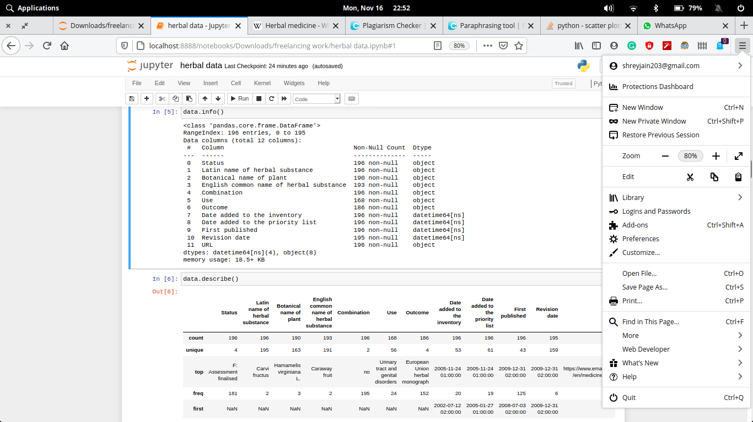

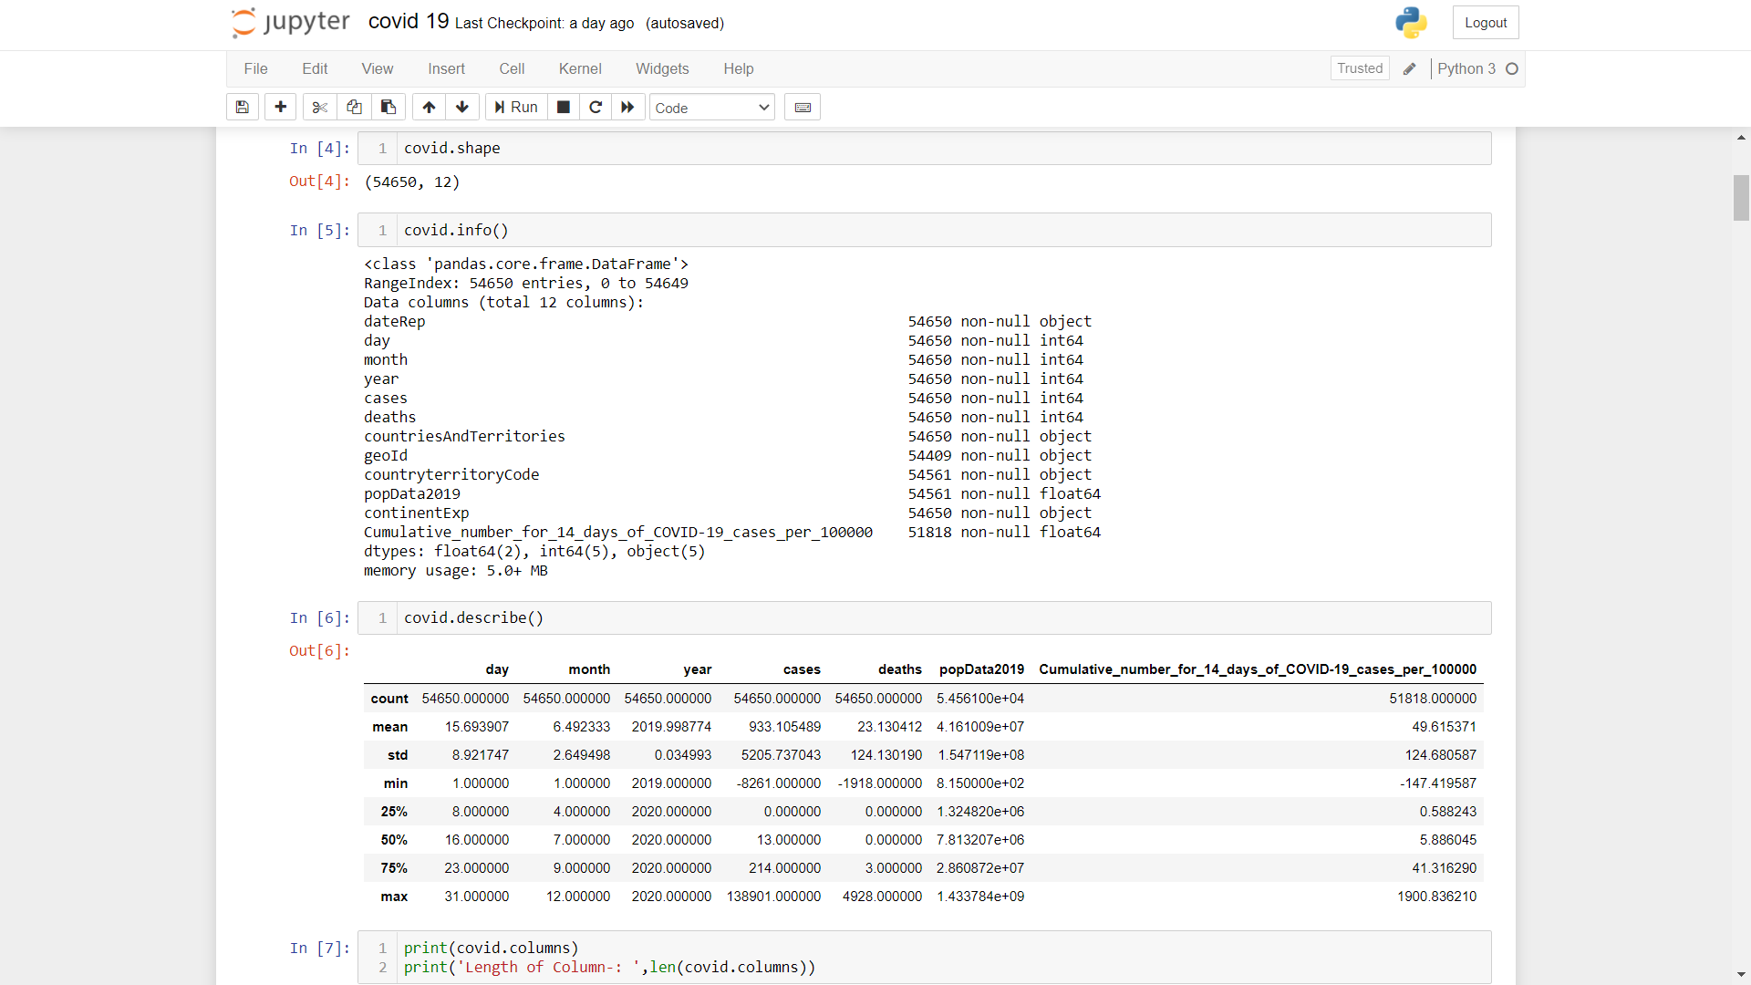

**Clean the unnecessary data, by removing, replace the missing data and renaming the columns.**

Dataset generally contains some null value, which is generally caused by misplacing some values. So its necessary to clean this mess from our dataset for better visualization

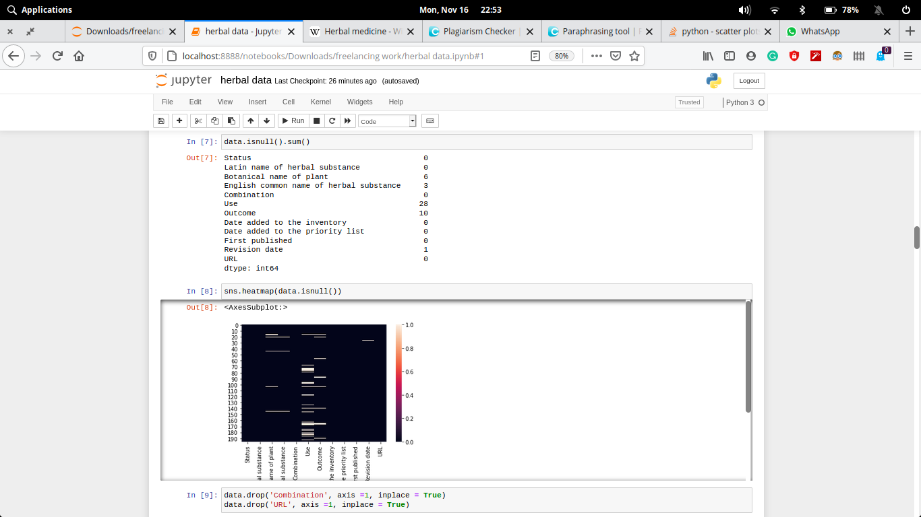

In the abo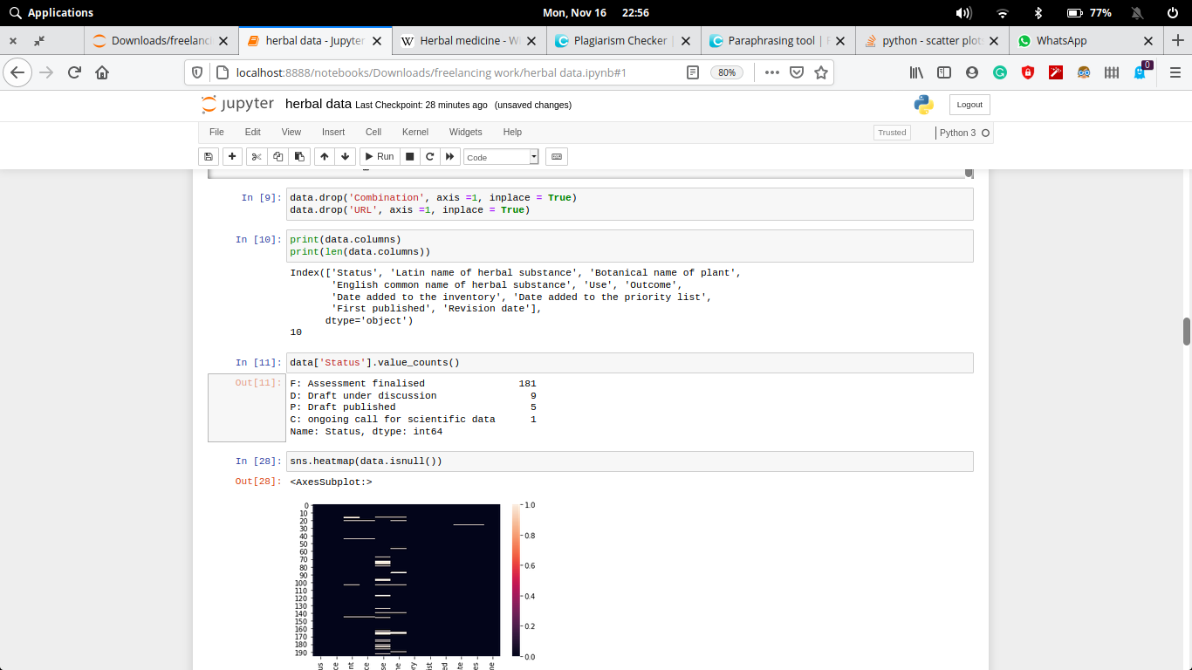ve diagram we see that some of the columns of this dataset contains null value.

In the process of data cleaning we first drop the particular column name **Combination** and **URL** which contains atmost same value. Then subsequently we fill the null values column with its mean value or 0, so that the values will not much more effect. Finally after all process our dataset is almost clean.

**why data clean needed (for your data)**

Data cleansing or scrubbing or appending is the procedure of correcting or removing inaccurate and corrupt data. This process is crucial and emphasized because wrong data can drive a business to wrong decisions, conclusions, and poor analysis, especially if the huge quantities of big data are into the picture.

# Data and Exploratory Analysis

**Code and its output with Explanation**

1. **What is the relation between the successive years and the new changes to a herbal medicine?**

This counts gives the estimated difference to make a change (upgrade most prob.). As the output is given in screenshot.

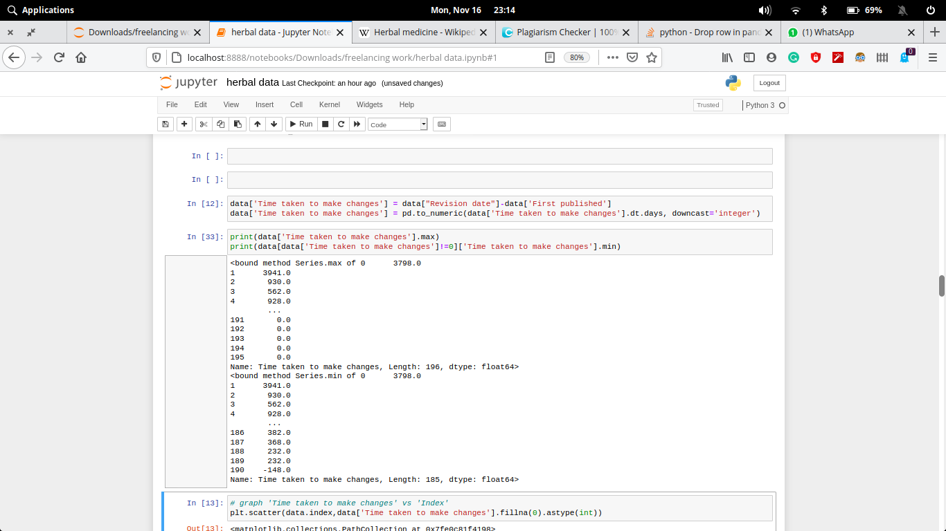

1. **What is the relation between the successive years and the average time to store a medicine in an inventory?**

This counts gives the estimated time difference to take an item from repository to the publishing area. As the output is given in screenshot.

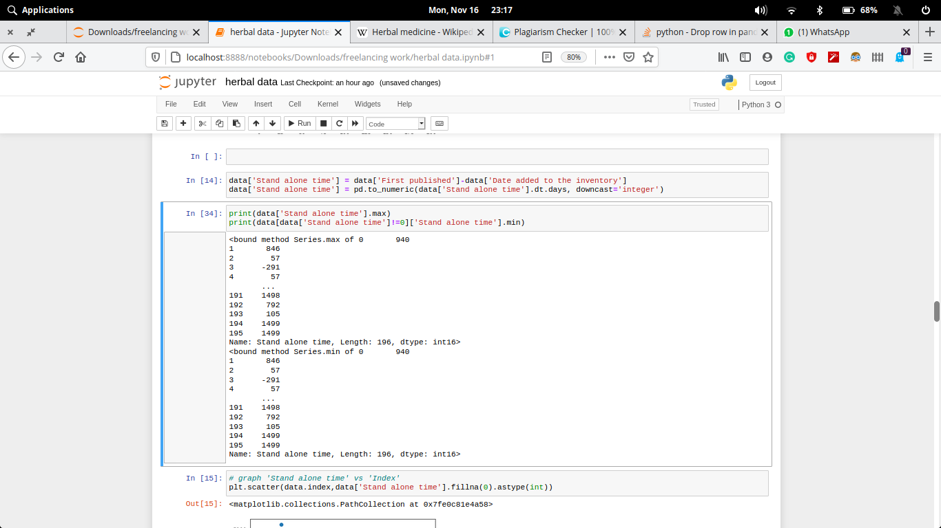

1. **What are the alternative medicines for a particular problem/disease?**

This counts gives the number of alternative medicines to a particular disease/condition. As the output is given in screenshot.

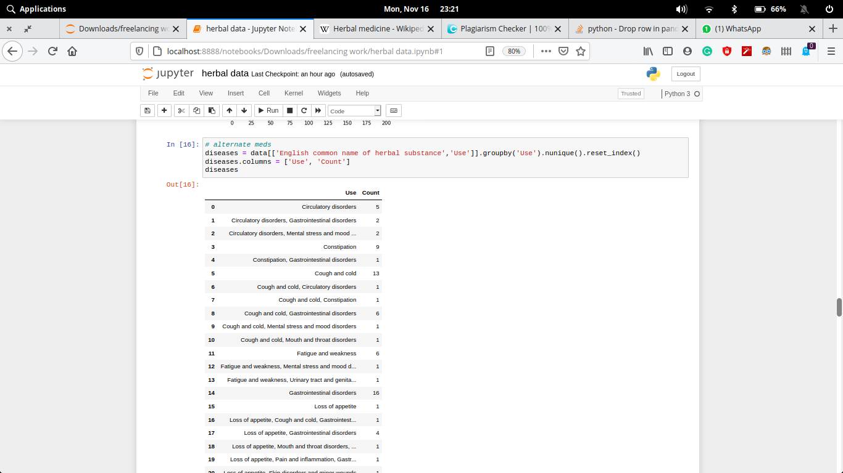

1. **Number of alternative medicines added in the last 5 years and if any new medicine is formed?**

This shows that there are only 9 diseases/conditions on which the herbal medicines are manufacturing. Out of which urinary track and genital disorders tops the research.

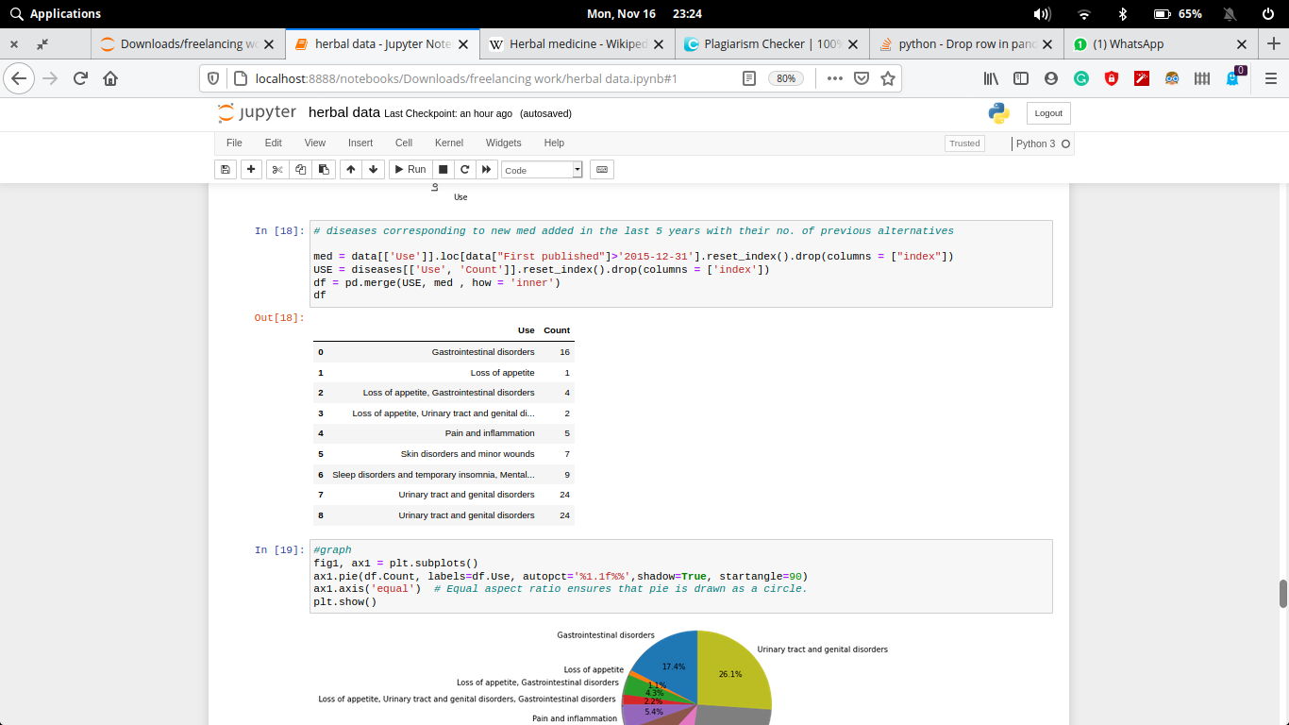

1. **Number of new medicines publishes in the last 10 years.**

In the last 10 years, 18, 4, 0, 15, 6, 2, 4, 4, 1, 1 herbal medicines are published respectively.

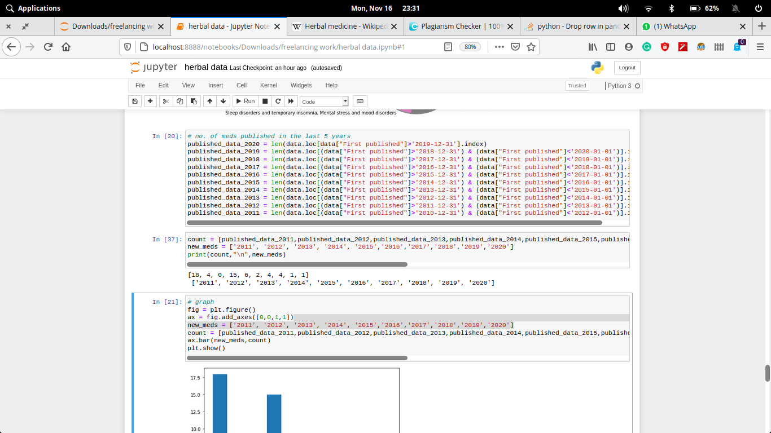

1. **Number of new medicines added to the invontory in the last 10 years.**

In the last 10 years, 16, 1, 0, 18, 6, 0, 3, 4, 0, 1 herbal medicines are published respectively.

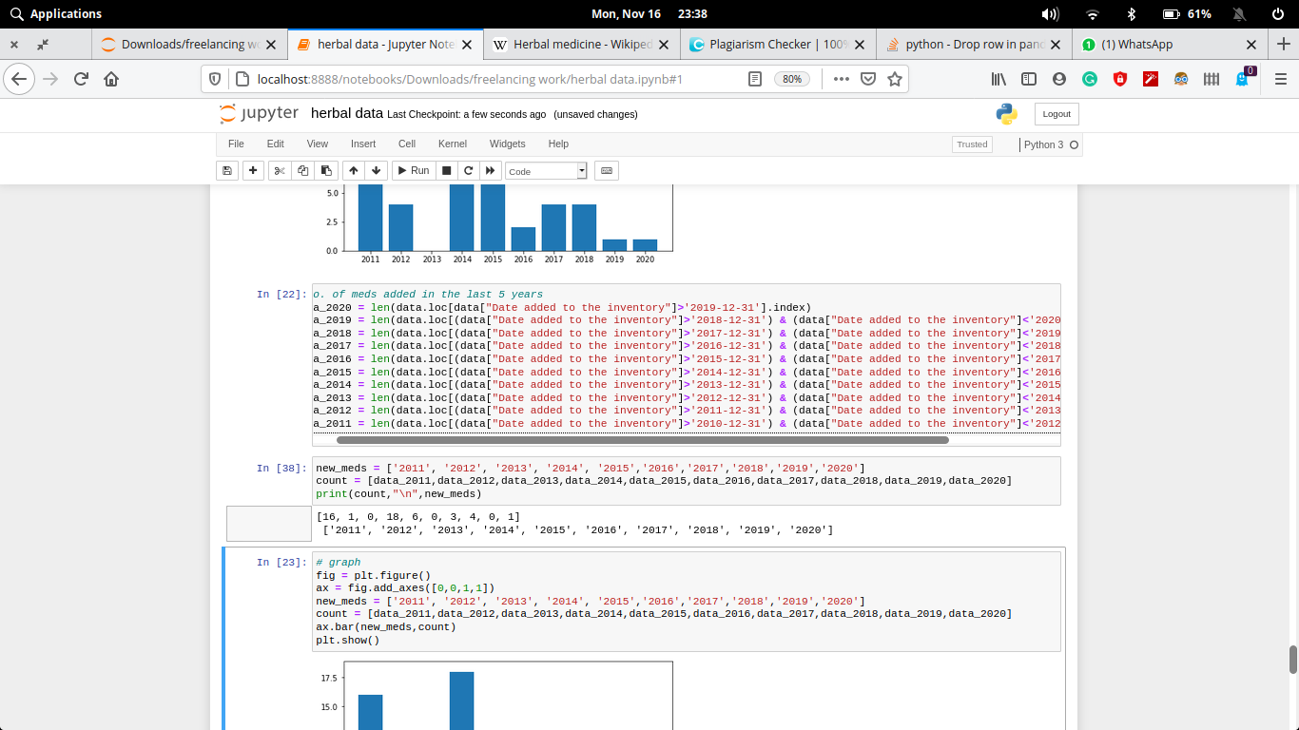

1. **Number of new medicines revised/upgraded in the last 10 years.**

In the last 10 years, 16, 1, 0, 18, 6, 0, 3, 4, 0, 1 herbal medicines are published respectively.

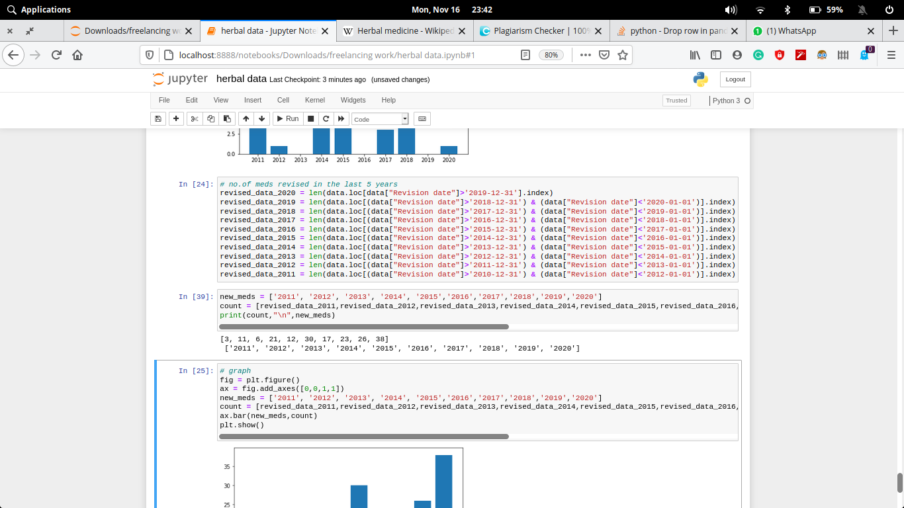

# Data Analysis – Visualization

**Code and its output with vizualization**

1. **What is the relation between the successive years and the new changes to a herbal medicine?**

**Code:-**

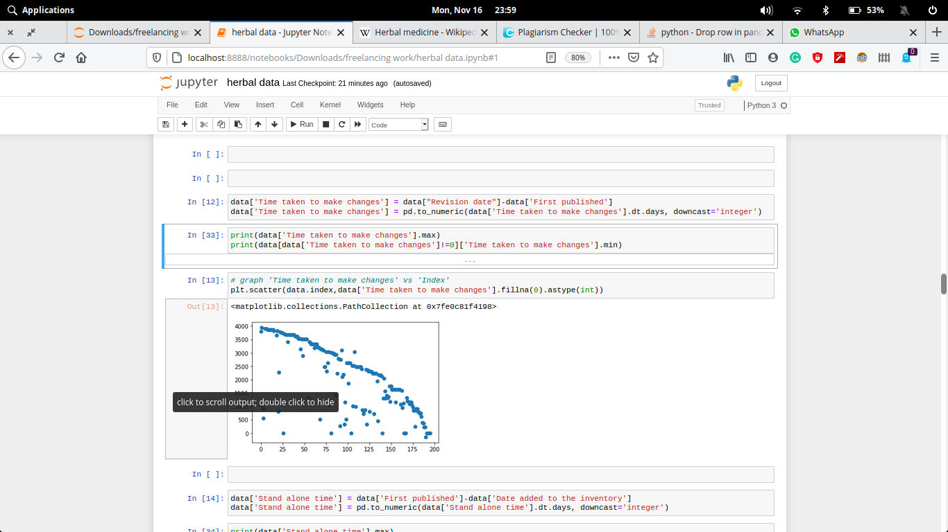

**Output:-**

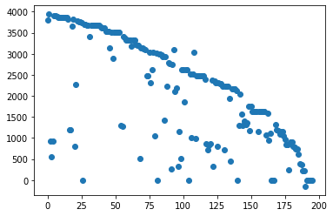

This visualization shows that as time increases, the waiting time to produce a new medicine decreases.

1. **What is the relation between the successive years and the average time to store a medicine in an inventory?**

**Code:-**

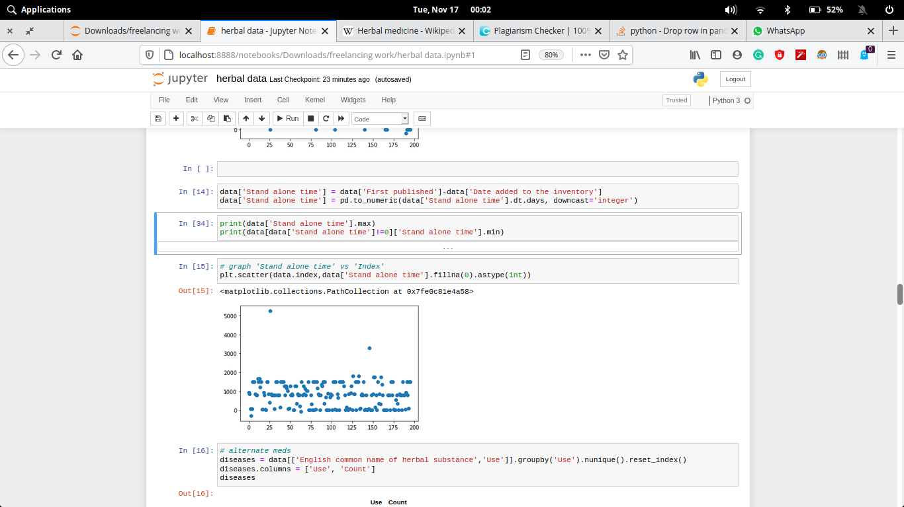

**Output:-**

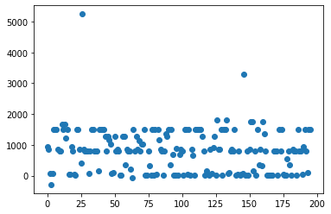

This is the graphical representation of total time taken to store a medicine raw material before it is passed to publish the medicine. Here, the graph is between the amount of days(y-axis) and year from 2010-01-01 till now(x-axis).

1. **What are the alternative medicines for a particular problem/disease?**

**Code:-**

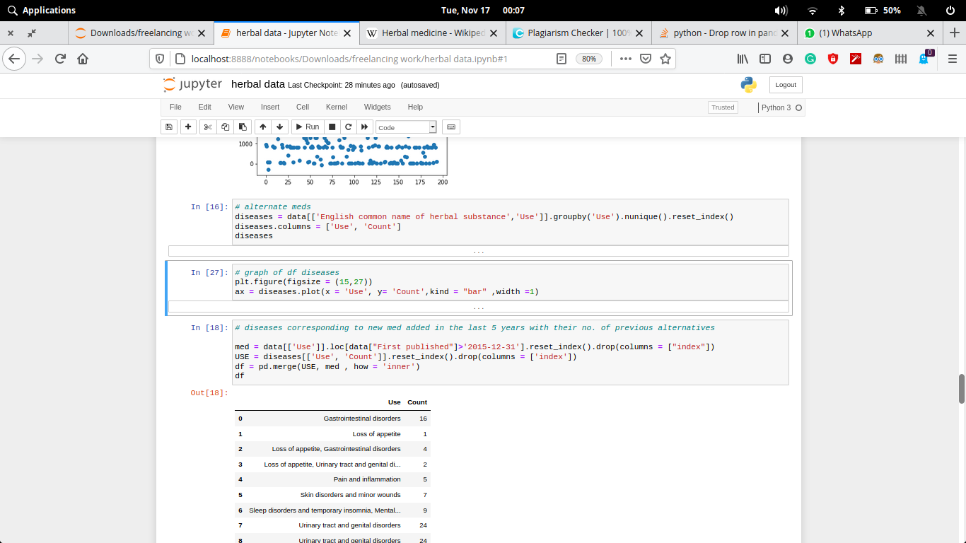

**Output:-**

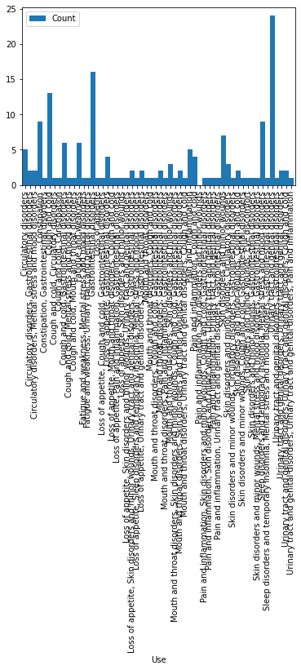

From this output, we can see that some disease like **Gastrointestinal disorders** have many alternative medicines, but some like **Mouth and throat disorders, Cough and cold** have very few alternatives or none at all.

1. **Number of alternative medicines added in the last 5 years and if any new medicine is formed?**

**Code:-**

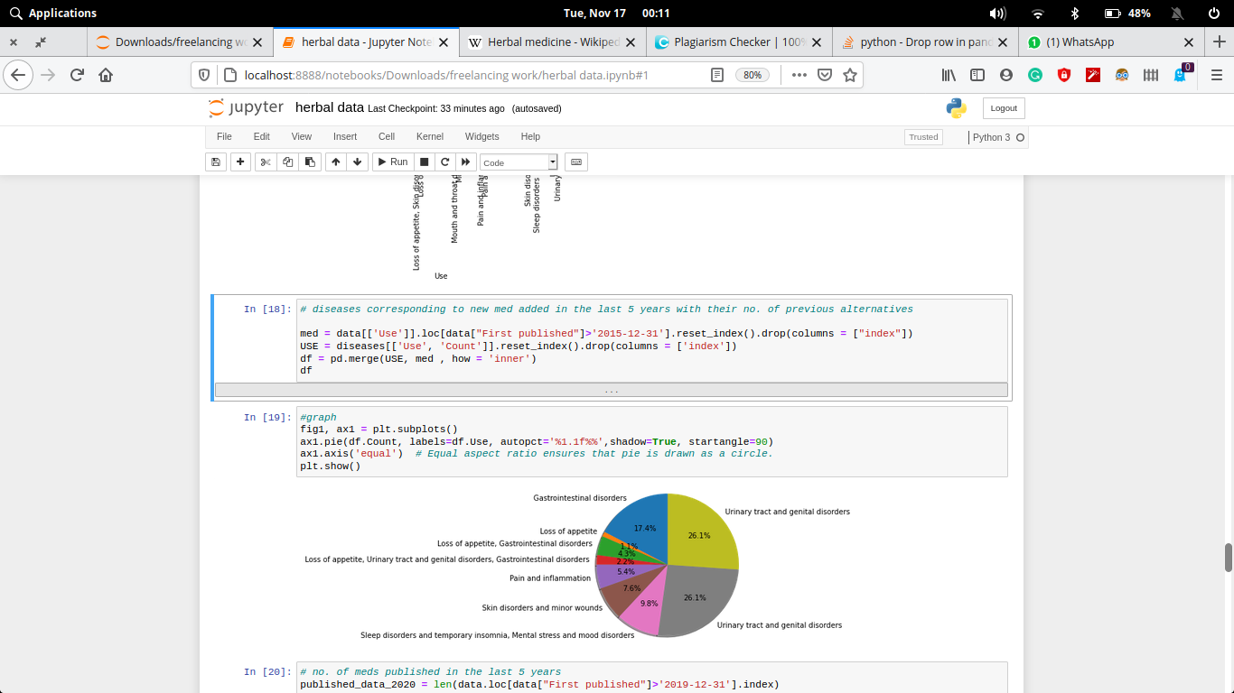

**Output:-**

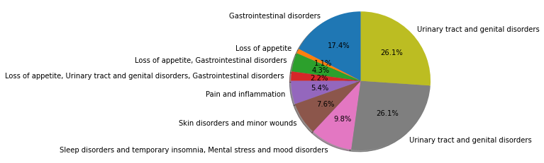

From this pie chart, we can see that medicines for some problems like urinary infection is in high demands, while some like problems loss of appetite is comparable to none at all.

1. **Number of new medicines publishes in the last 10 years.**

**Code:-**

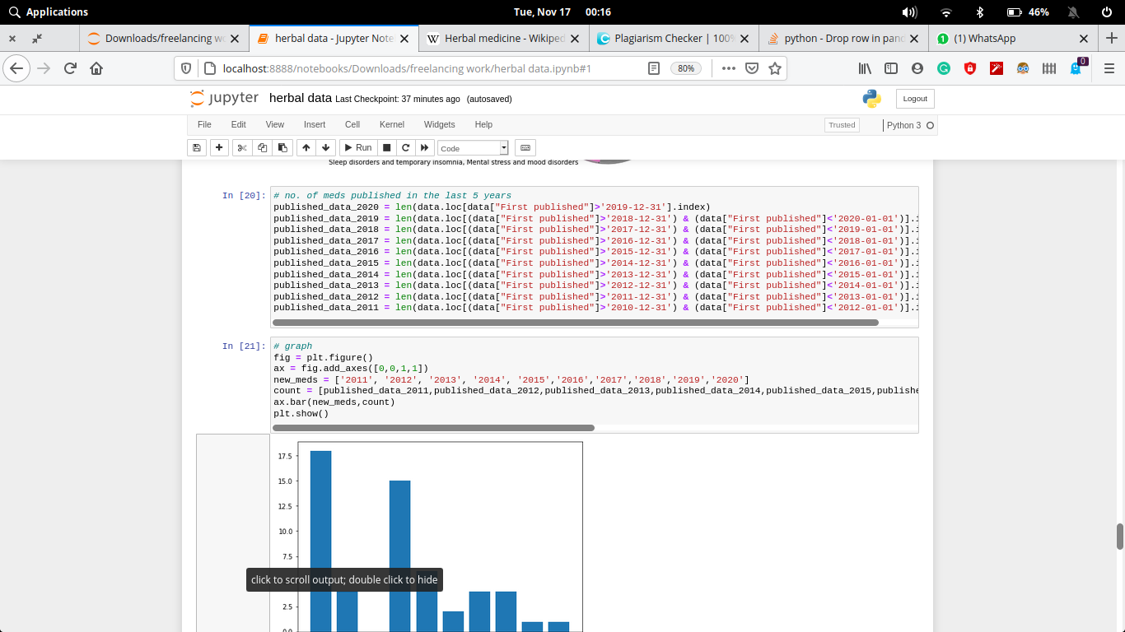

**Output:-**

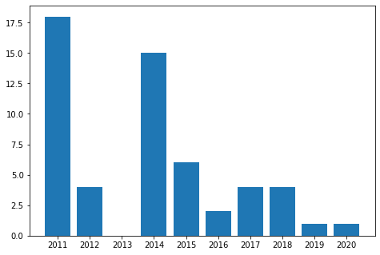

From this bar chart, we can see that compared to years like 2011, 2014, the years like 2019,2020 have not published much medicines. In 2020, even with the rise of covid-19, the publishing is so less i.e., either the sufficient data is not received yet, or company is going through some sort of issues.

1. **Number of new medicines added to the invontory in the last 10 years.**

**Code:-**

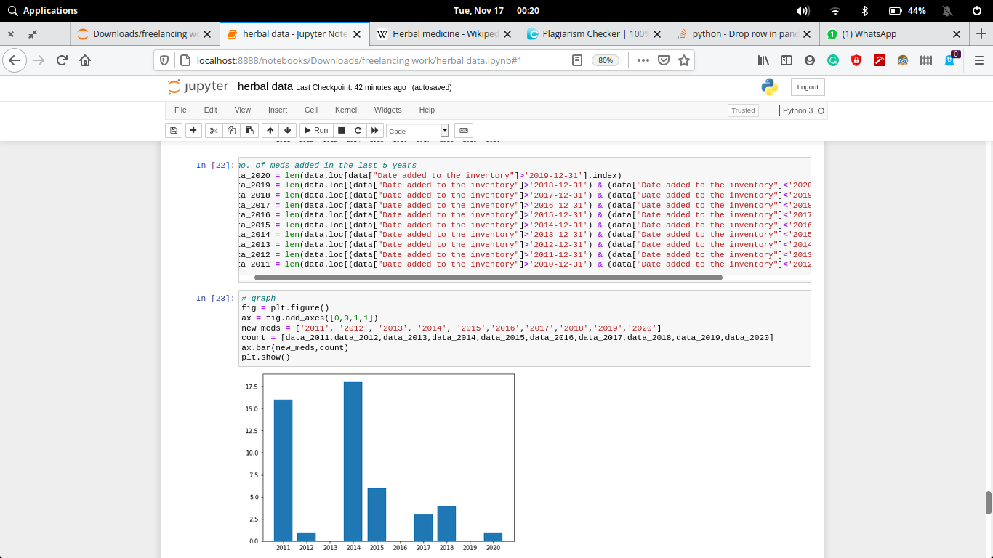

**Output:-**

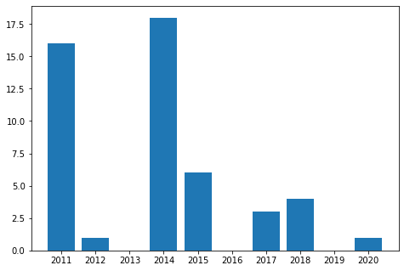

From point 5, we conclude that in 2019, 2020 there’s been some reason through which enough medicines is not published. From this graph, we can say that due to lack of material in the inventory, the company is unable to publish. The lack of availability can be due to any investment issue or has not much sufficient man power.

1. **Number of new medicines revised/upgraded in the last 10 years**

**Code:-**

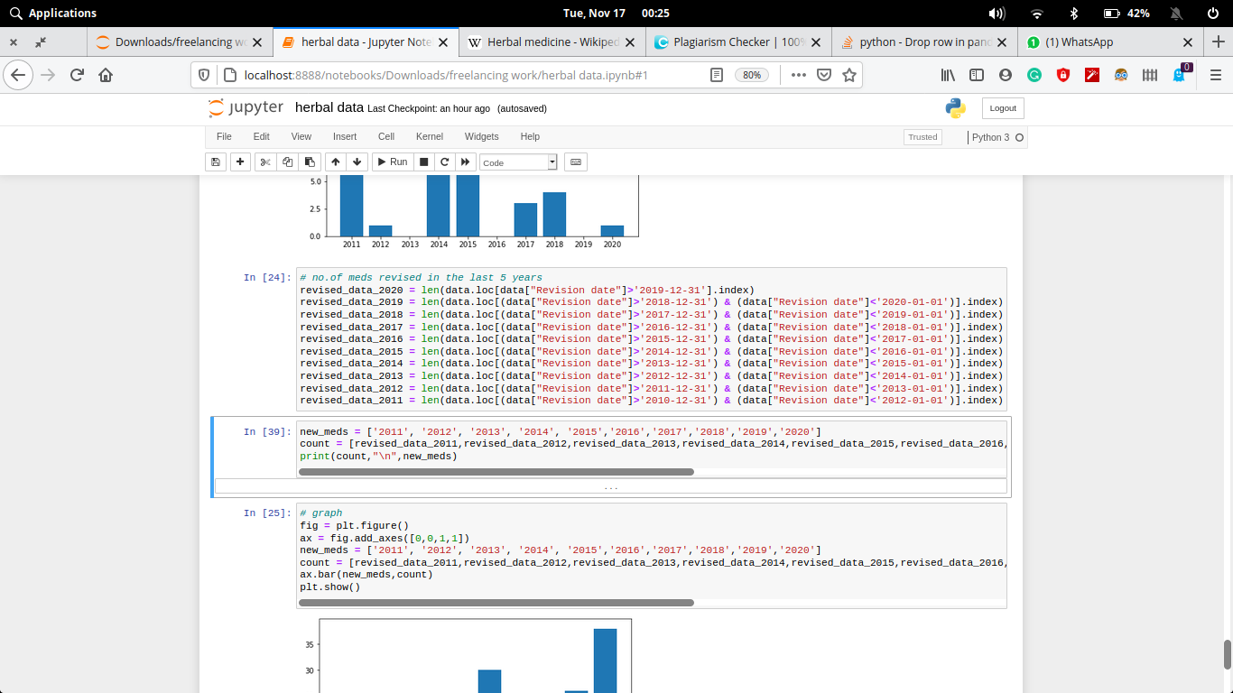

**Output:-**

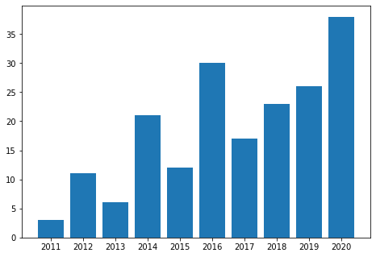

In spite of lack of inventory and publishing of new medicines, the up-gradation / revision of previous medicines are up to date. Which means the staff is doing their job very well.

# Executive Summary

**CONCLUSION**

From the above observations, we concluded:

1. With the increase in technology, the time to upgrade any medicine decreases but the average time requires to kept the raw product in the inventory remains the same.

2. In the last 5 years, we have discovered medicine for only one condition: Loss of appetite, and different medicine are manufactured for urinary track and genital disorders.

3. As compared to 10 years age, we are producing and publishing very less, but revising a lot. It shows that either no new disease/condition is being produced, or we are unable to make a medicine for that.

# References

* [www.globaltimes.cn](http://www.globaltimes.cn/)
* <https://data.europa.eu/euodp/en/data>
* https://en.wikipedia.org/wiki/Herbal_medicine